**Internship Project Summary**

**Name: Surya Prakash G  
Internship ID: WD100191  
Company: DATASOFTIXS  
Duration: 4 Weeks  
Date: January 2025**

**Week Project 1: Storyteller’s Haven  
  
Objective:**

To build a blog template for aspiring writers or bloggers.  
  
**Explanation:**

The blog template includes a homepage with blog post previews and a navbar with categories. A light/dark mode toggle was added to enhance user experience.

**Tools and Technologies Used:**

* HTML, CSS, JavaScript
* Grid layout for responsiveness
* Light/Dark mode toggle

**Output Result:  
  
**

**Light Mode  
  
**

**Dark Mode**

**Week Project 2: Task Master**

**Objective:**

To develop a dynamic to-do list application.  
  
**Explanation:**

The application enables users to add, mark as complete, and delete tasks. Tasks are stored in local storage to ensure persistence across sessions.

**Tools and Technologies Used:**

* HTML, CSS, JavaScript
* Local storage for data persistence

**Output Result:**

**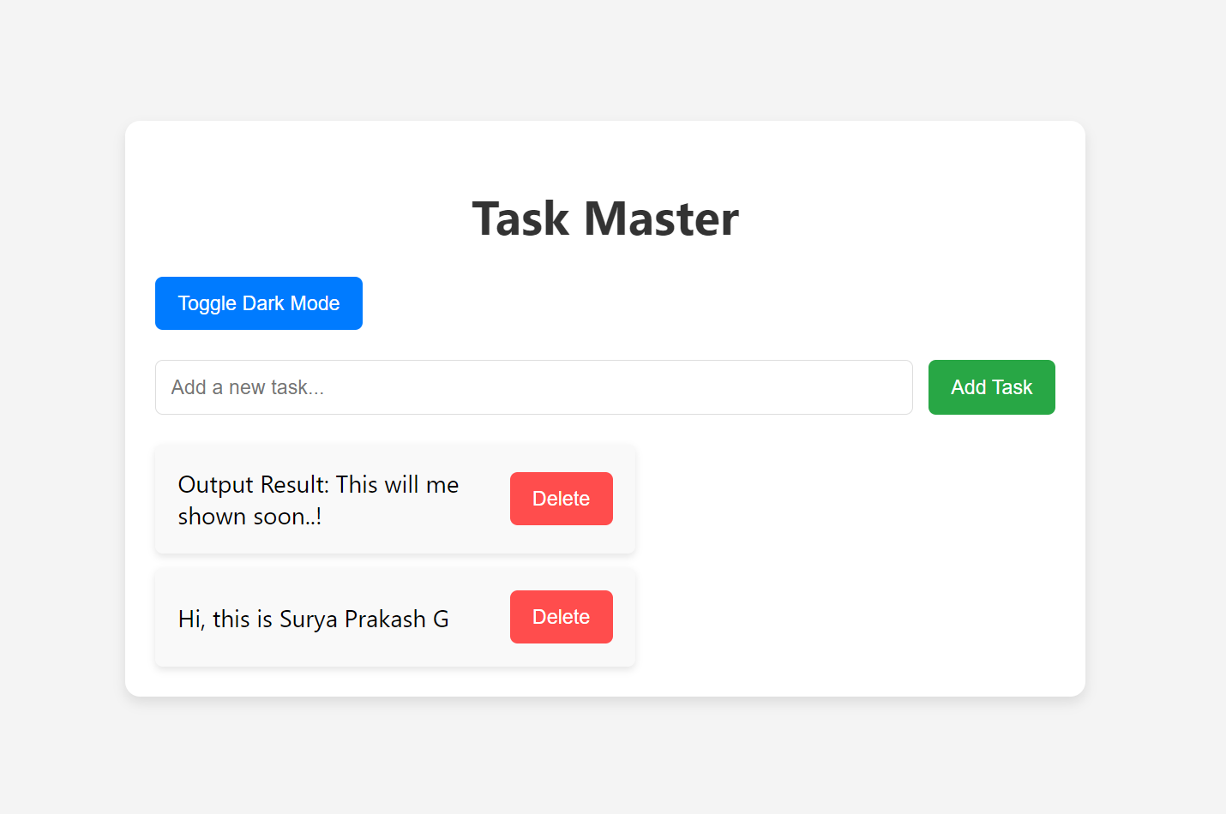  
  
Light Mode**

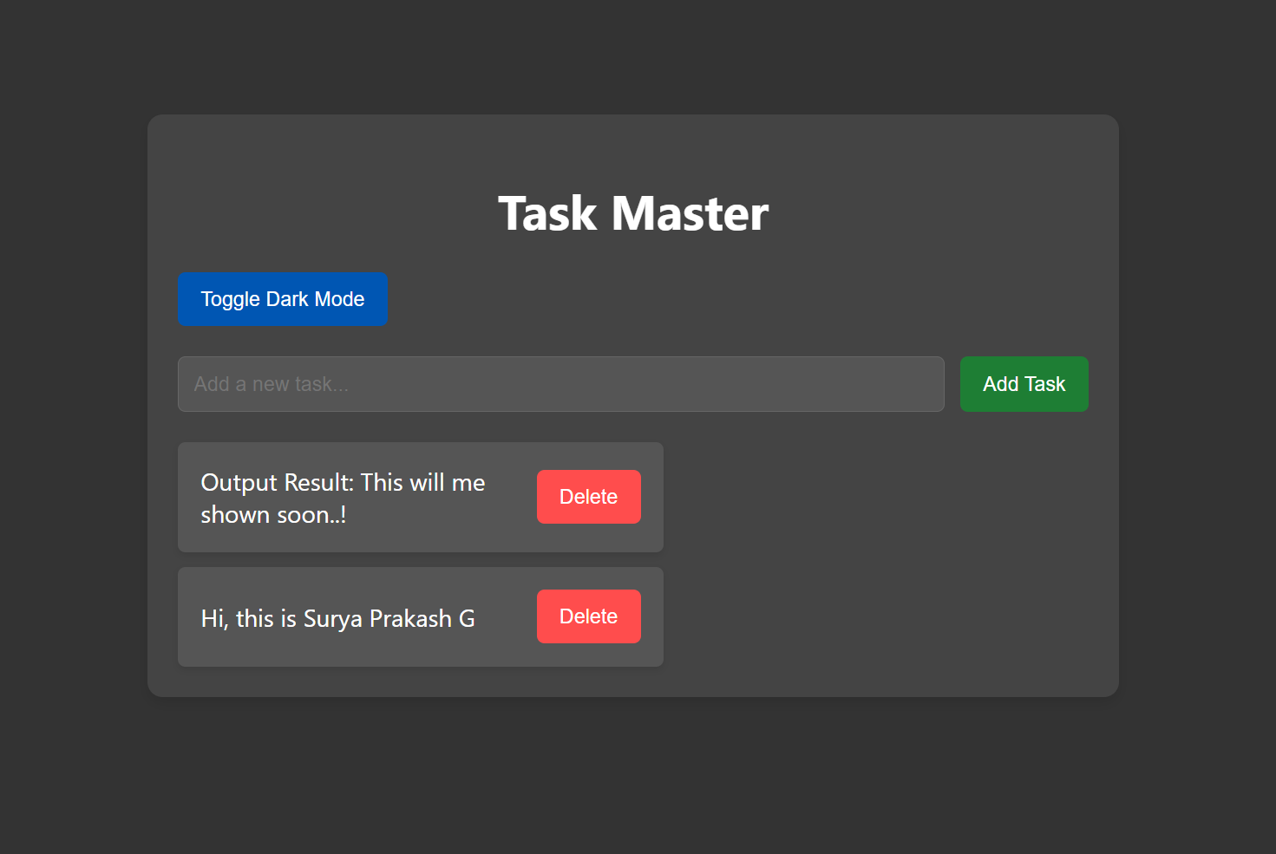

**Dark Mood**

**Project 4: Skywatcher’s Companion**

**Objective:**

To design a weather dashboard providing real-time weather updates.

**Explanation:**

The weather dashboard fetches and displays weather details like temperature, humidity, and conditions. Users can search for weather updates by city.

**Tools and Technologies Used:**

* HTML, CSS, JavaScript
* OpenWeatherMap API

**Output Result:**

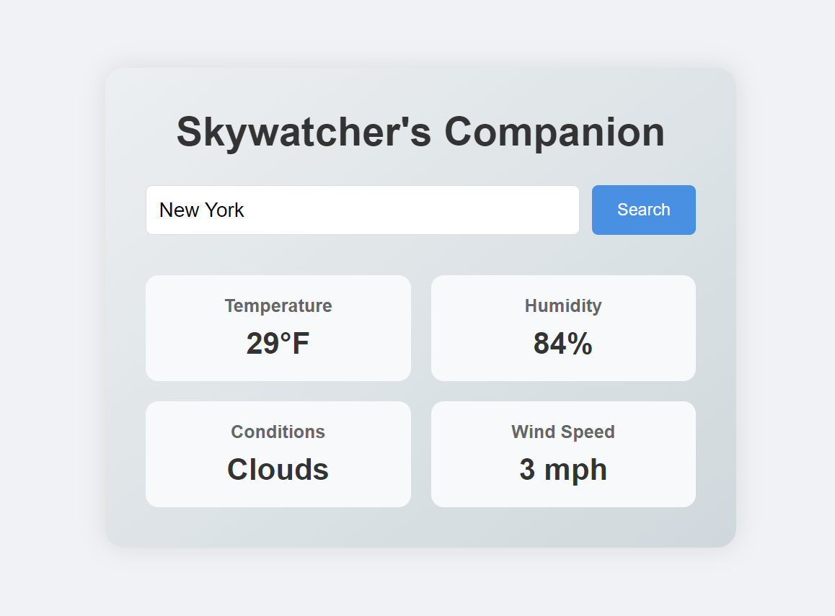

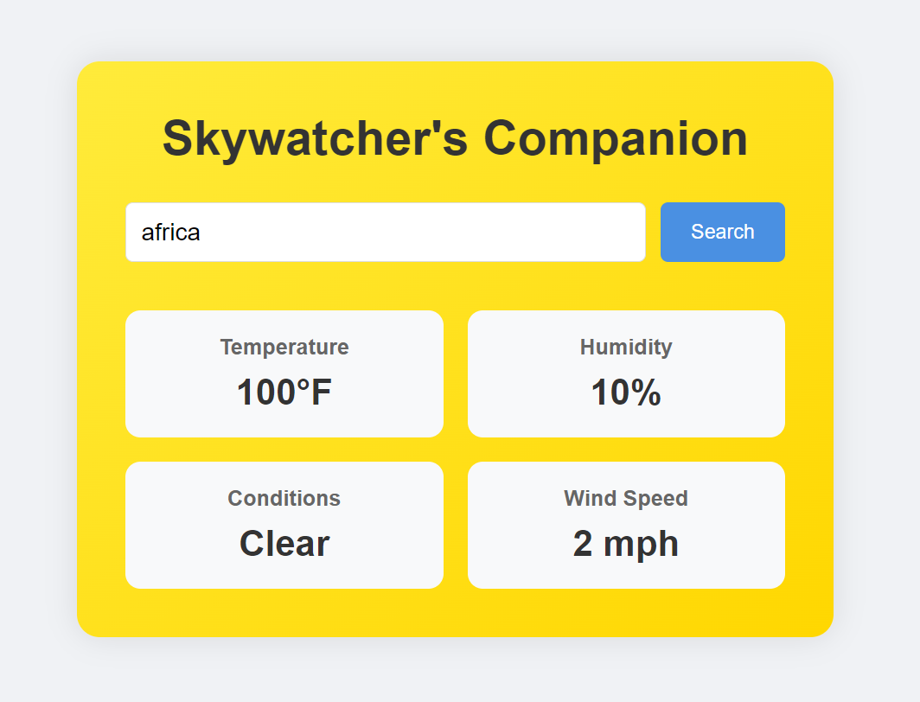

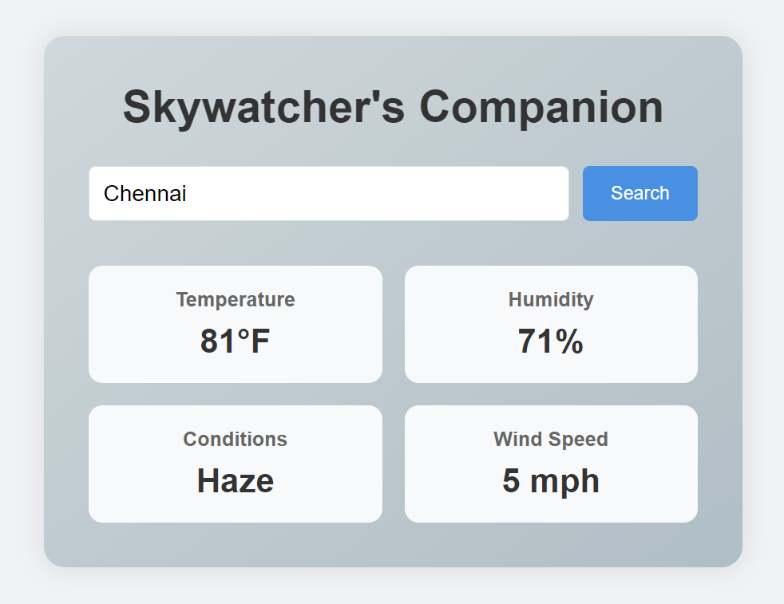

**Summary of Learnings**

During the internship, I gained hands-on experience in:

* Responsive web design using Flexbox and Grid layouts.
* JavaScript for interactive features and API integration.
* Creating user-friendly interfaces with modern web design practices.
* Using version control with GitHub to manage and showcase projects.

This internship has significantly enhanced my web development skills and provided me with practical knowledge of implementing creative ideas into functional projects.

**GitHub Repository Link -** [**[GitHub Link Here]**](https://github.com/Aries-Surya/WD100191)